Monday:  Sept. 3rd | Tuesday  Sept. 4th | Wednesday:  Sept. 5th | Thursday:  Sept. 6th | Friday:  Sept. 7th
Science: 10:00-11:00  Lesson 1:  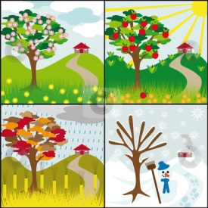  Introduction into the Seasons | Science: 10:00-11:00  Lesson 2:  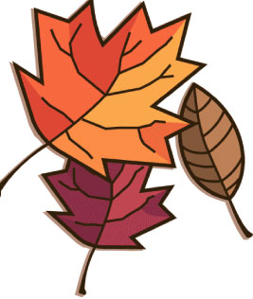  Exploring the season of Fall | Science: 10:00-11:00  Lesson 3:  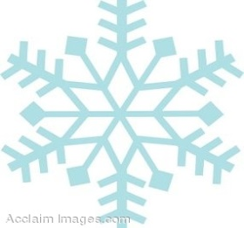  Exploring the season of Winter | Science: 10:00-11:00  Lesson 4:  Exploring the season of Spring  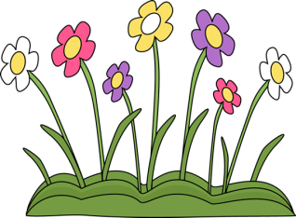 | Science: 10:00-11:00  Lesson 5:  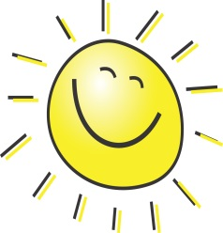  Exploring the season of Summer
Seasons Unit Time Line

